You are given the root node of a binary search tree (BST) and a value to insert into the tree. Return *the root node of the BST after the insertion*. It is **guaranteed** that the new value does not exist in the original BST.

**Notice** that there may exist multiple valid ways for the insertion, as long as the tree remains a BST after insertion. You can return **any of them**.

**Example 1:**

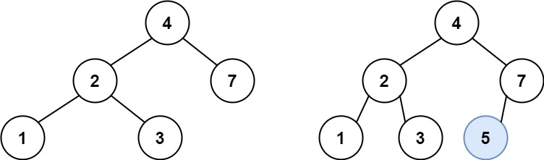

Input: root = [4,2,7,1,3], val = 5  
Output: [4,2,7,1,3,5]  
Explanation: Another accepted tree is:

**Example 2:**

Input: root = [40,20,60,10,30,50,70], val = 25  
Output: [40,20,60,10,30,50,70,null,null,25]

**Example 3:**

Input: root = [4,2,7,1,3,null,null,null,null,null,null], val = 5  
Output: [4,2,7,1,3,5]

**Constraints:**

* The number of nodes in the tree will be in the range [0, 104].
* -108 <= Node.val <= 108
* All the values Node.val are **unique**.
* -108 <= val <= 108
* It's **guaranteed** that val does not exist in the original BST.